How to Run the Sound Room

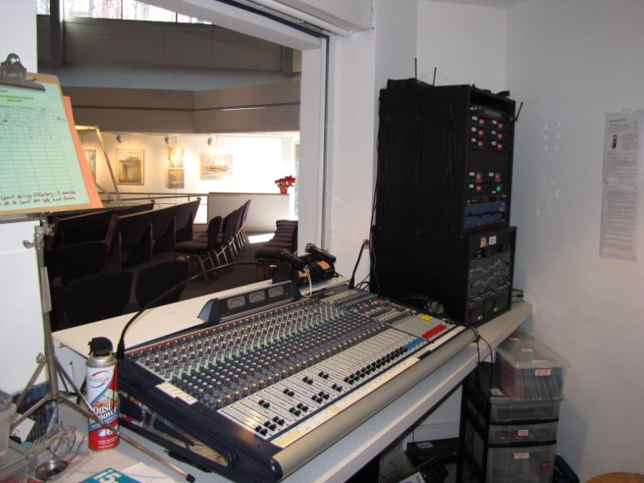

Community Church of Chapel Hill

Jan 08, 2012 V2a DRAFT Copyleft C3HUU

Table of Contents
Table of Contents 2
Credits 2
History: 3
Copyleft: 2011, 2012 C3HUU 3
Summary 4
Before Each Service: 4
During Service: 4
After Service: 4
Setting up for service (9:30 only) 5
Wake-Up (9:30 only) 5
Set-Up Mics (9:30 only) 6
Set up pulpit mic 6
Set up Joys and Concerns mic 6
Set up AudioTechnica 180 mic if needed 7
Cordless mic(s) 8
Checklist: Pre-Service 9
Checklist: During Service 10
Checklist: After Service 11
Trouble-Shooting: 12
No Sound in Sanctuary 12
No sound in lobby 12
Master Power Switch Fails 12
Ringing in Sanctuary 12
No sound in Hearing Assist Headphone Devices 13
Squealing feedback 13
Distorted sound 13
Reference 14
AUX channels 14
Reference: Backstage room 14
Reference: Hardcopy Manuals 14
Materials To Be Updated and Referenced 14

Credits

Manual Authors: Steve Marshal (V1), Mark Smith (v2)
Soundroom Technical Leads: Spence Foscue, Steve Marshall, Mark Smith

History
- Initial version created 2010-02-01 SM
- V1a: Minor updates to initial version 2011-01-03 MS
- V2: Updated with new online services information, TOC, posted on 2012-01-04 MS
- V2a: Content updates on Dockstar/Pogoplug and document restructuring posted on 2012-01-08 MS

Copyleft 2011, 2012 C3HUU
Community Church of Chapel Hill, Unitarian Universalist
- http://c3huu.org

For more information or to submit updates or corrections, please contact Soundroom@c3huu.org
Summary

Before Each Service:
- Turn on the master power switch (9:30 only)
- Set up mics
- Turn Digital Audio Recorders on and into Record Mode

During Service:
- Monitor Sound Levels
- Record the service (right-hand Audio Recorder)
- Record the sermon (left-hand Audio Recorder)
- Let CRE know when the offertory is in progress
- Attendance Count for Membership

After Service:
- Turn Digital Audio Recorders into USB mode for 5 minutes
- Put mics away (11:15 only)
- Power off (11:15 only)
- Turn off Digital Audio Recorders (11:15 only)

Setting up for service (9:30 only)

Wake-Up (9:30 only)
- Turn on the master power switch
- Wait 10 seconds while everything turns on
NOTE: there is a workaround if the master power switch fails, see Troubleshooting section

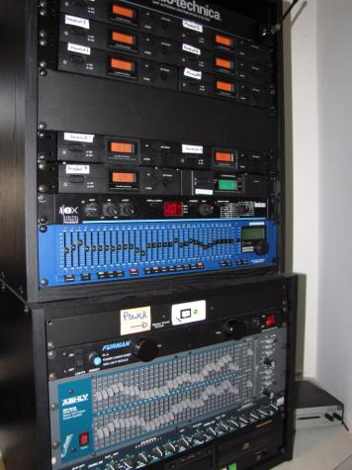

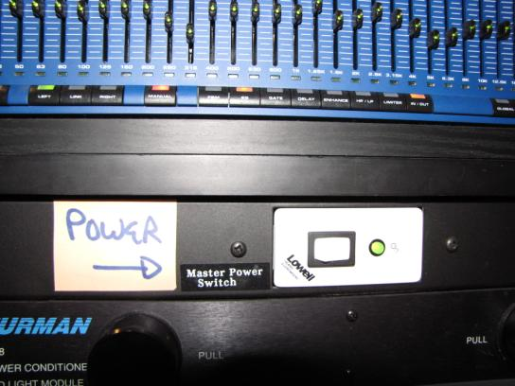

Set-Up Mics (9:30 only)

Set up pulpit mic
  - Mic is stored in the soundroom
  - Screw it onto base (on pulpit)
    - Insure that black windscreen is attached
  - Plug it into channel 10 (stage box in floor, stage right).

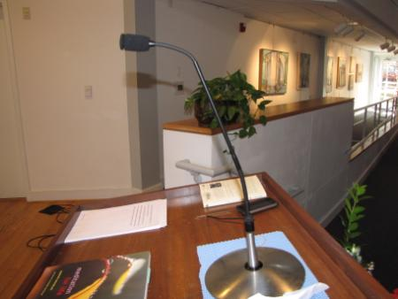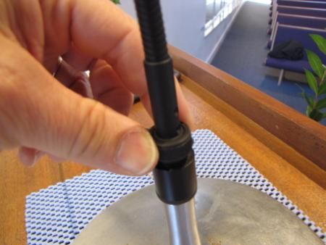

Set up Joys and Concerns mic
  - AKG mic (stored in black hard cover cases, on left of sounddesk).
  - Joys and Concerns mic stand should be next to the chalice
  - Should be plugged it into channel 4 (stage box in floor, center stage)

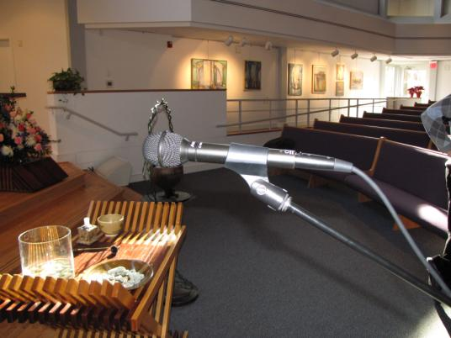

Set up AudioTechnica 180 mic if needed
  - Used for youth choir, children’s choir, community church singers, solo performers or small ensembles.
  - Use mic stand at the center of stage.
  - Side of the mic with the circle icon should be facing towards the performer.

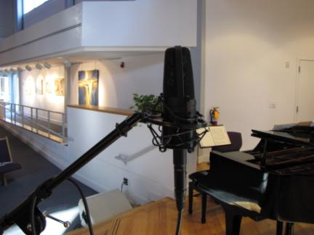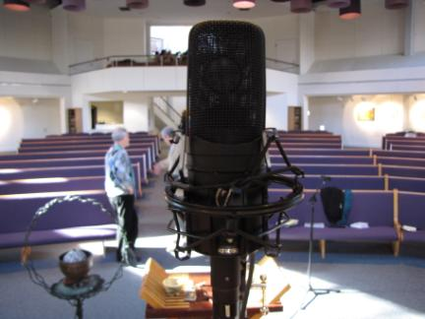

Cordless mic(s)
  - Stored in soft-cover cases to left of sound desk.
  - These mics are on channels 11- 13 on the desk (“cordless handheld 1,2 & 3”)
  - “ON” switch is on bottom of mic
    - Red Light is on when mic is on

  - Use one for greeting of visitors during the Welcome part of Service
  - Ask the Greeters (people who hand out order of service) to take the mic around (ask them before the service starts)
  - NOTE: Cordless mic #3 is undergoing repair 1Q2012

Checklist: Pre-Service
- Master faders should be at 0
  - Masters are yellow faders on righthand side of desk
- All channel faders should be between -5 and 0
  - Channel faders are black and on left side of desk
- Make sure MUTE button (red light) for each channel is off
- Say a few words into each mic to make sure they are working (or use PFL button)
- If they are not working, see trouble-shooting list below

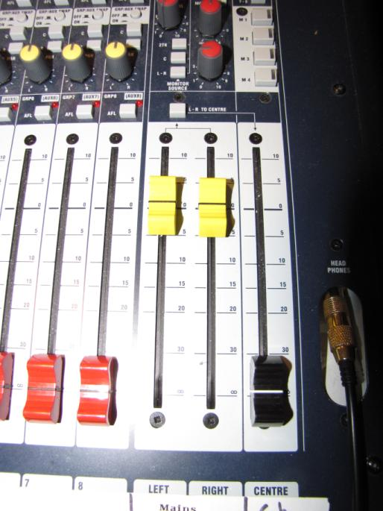

Checklist: During Service

- Adjust volume level for each channel s using faders
  - Channel 4: Joys and Concerns
  - Channel 4: 180^{O} mic on stage
  - Channel 10: pulpit

- Push MUTE button if you need to mute a channel.
  - RED light comes on when the channel is muted.

- Record Entire Service using Digital Audio Recorder on right

- Record Sermon using Digital Audio Recorder on left

- Count attendance
  - Its okay to count one side and double the number
  - During the offertory is the preferred time to count

- Let CRE know when the offertory starts
  - Use Family Radio or walk over to Jones Building NOTE: this task is under review in 1Q2012.
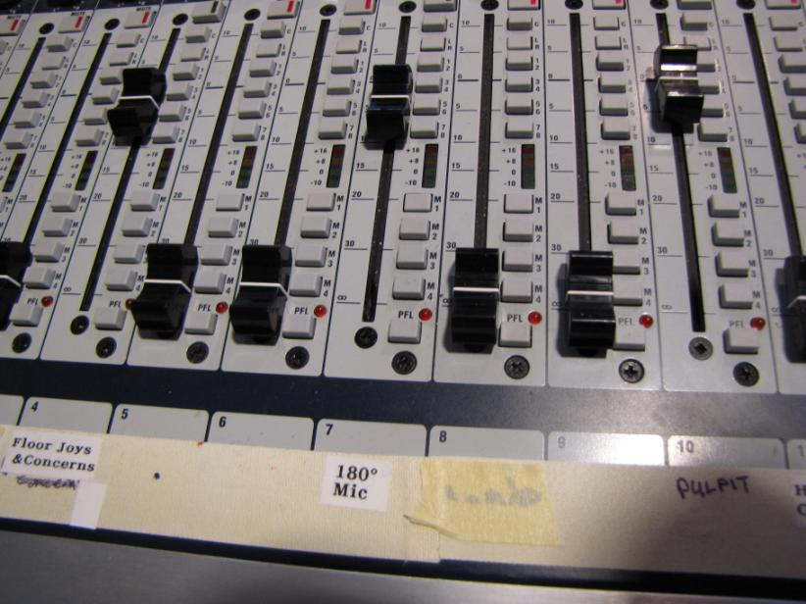

Checklist: After Service

- Plug Digital Audio Recorders into Dockstar
  - Plug both into dockstar
  - Does not matter which one goes into which channel
  - The audio recording are automatically uploaded

- Mute all channels (11:30 only)

- Power down entire system using master switch. (11:30 only)
  - The white switch marked “power” powers off all systems

- Put mics away in sound room (11:30 only)
  - Leave the mic stands and cables out

- Lock up soundroom (11:30 only)

Trouble-Shooting:

No Sound in Sanctuary
- Check the red GAIN knob for each channel (at top of board)
  - Should be around 2 o’clock position
- Make sure channels 4, 7, & 20 are UNMUTED
  - RED light is lit when channel is MUTED
- Faders for channels 4, 7, & 10 (black faders) between -5 and 0
- Master (yellow) faders should be between -5 and 0
- Master power switch should be on
- Make sure all power switches are ON in the rack of equipment to the right of the desk.

No sound in lobby
- Check the amp is on for the sound in the lobby (silver box on left)
- Check volume control for lobby (right-hand side of board, should be at about 10 o’clock position)
- Make sure channels 4, 7, & 20 are UNMUTED
  - RED light is lit when channel is MUTED

Master Power Switch Fails
- There is a small reset switch where the rack is plugged in. This may be selected manually using a small screwdriver (in top drawer)

Ringing in Sanctuary
- Too much gain or volume in onstage monitors

No sound in Hearing Assist Headphone Devices
- Check volume control for Hearing Assist (right-hand side of board, should be at about 10 o’clock position)
- Make sure channels 4, 7, & 20 are UNMUTED
  - RED light is lit when channel is MUTED

Squealing feedback
- Something is turned up too high – too much gain or volume
- Bring down master faders and slowly ease them back up

Distorted sound
- Something is turned up too high – too much gain or volume
- Look for a channel that has is showing a lot of RED on the fader LEDs, or has the red light by GAIN knob that is on all the time or else is flashing on and off at lot. Turn down the gain in that channel.

Reference

AUX channels
AUX1 – onstage monitor
AUX2 – monitor in ceiling of sanctuary
AUX3 – plug in monitor
AUX4 – plug in monitor
AUX5 – reverb
AUX6 – CD recorder

Reference: Backstage room

- Extra mic cables are stored on orange roll-up in backstage room
- Extra mic stands are in backstage room

Reference: Hardcopy Manuals

See ringbinders to left of sound desk and separate manuals in the drawers below the rack with the Master Power Switch.

Materials To Be Updated and Referenced

- Madonna mics – need photos
- List of channels on the board
- Sketch (or photo) of Soundroom with all major components labelled
- Diagram of Soundroom interconnects (Conceptual)
- Wiring diagram of all connections (Detailed Operational)

